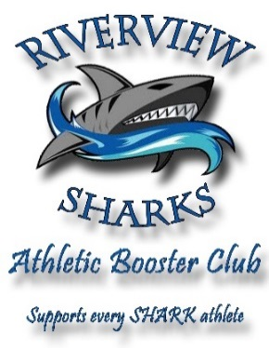

Requirements: BLACK & WHITE camera-ready art work or business card. Email electronic art files to: [andrea.hendrickson@sdhc.k12.fl.us](mailto:andrea.hendrickson@sdhc.k12.fl.us) Please send picture files in jpeg. Format.

Photographs are also allowed. Please add to final total.

***The Riverview High School***

***Athletic Booster Club*** invites you to join us in supporting the athletes of Riverview High School by sponsoring space in our sports books. The Boosters appreciate your concern for the educational advancement of our teenagers.

**AD SELECTION**

BACK COVER (11” H x 8 ½” W) Color $300.00

~~INSIDE FRONT COVER (10” H x 7 ½” W) $250.00 SOLD~~

INSIDE BACK COVER (10” H x 7 ½” W) $250.00

FULL PAGE (10” H x 7 ½” W) $200.00

HALF PAGE (5" H x 7 1/2" W) $120.00

QUARTER PAGE (5" H x 3 3/4" W) $ 70.00

EIGHTH PAGE (business card -2 1/2h X 3 3/4 " W) $ 50.00

PATRON LISTING (maximum 50 characters per line) $ 5.00 X no. of lines

* **CASH/CHECK #**
* **TOTAL RECEIVED**

**THANK YOU FOR YOUR CONTINUED SUPPORT. PLEASE MAKE CHECKS PAYABLE TO:**

**RIVERVIEW HIGH SCHOOL ATHLETIC BOOSTER CLUB**

Company/Patron Name

Company Contact Phone

Mailing Address Zip

Athlete's Name Athlete's Sport

# RIVERVIEW ATHLETIC BOOSTER CLUB - 11311 Boyette Rd., Riverview, FL 33569

CONTACT INFORMATION for program **only**: Andrea Hendrickson: 609-870-1464 (c)

Andrea.hendrickson@sdhc.k12.fl.us